# **ECE 4950 Project 1**

Setting Up a Device to Receive and Transmit Data

Group 15: Wilhem Davis, Jaiden Beck, Drew Buley,

Price Purvis, Chad Stark

Date Performed: 9/16/25

**Executive Summary**

This lab focused on exploring the hardware and software available with the Arduino and MATLAB/Simulink. By the end of the lab, lab members would gain some basic understanding of the Simulink software. The goal of the project was to have a motor that would turn on or off based on the signal that was received from a potentiometer. A potentiometer is a dial that sends an output voltage based on how far the dial is turned. The potentiometer was wired to the analog in ports on the Arduino and turned the dial to verify that it was correctly sending a signal. When it correctly sent a signal, the servo motor was wired to the ports labeled digital PWM on the Arduino. The motor was sent a signal, and when it turned on, the next goal was to use the potentiometer signal to turn the motor on. Simulink was used to handle the output from the potentiometer and use that output to control the servo motor. A switch block compared the potentiometer’s input to a target threshold. When the potentiometer was turned clockwise to a degree above this threshold, the motor was turned on. When it was turned back to a position below this threshold, the motor turned off. In addition to performing this function with the hardware, a 3D model of a pool stick debossed with our team’s number was created.

**Materials and Methods**

MATLAB/Simulink R2025a was used to do the modeling, and the Arduino Mega 2560 was used to wire the hardware. The potentiometer was a Bourns 3296 potentiometer, and the servo motor was a Towerpro MG92B. The Arduino USB was used to connect a laptop to the Arduino, and standard wires were used with a breadboard to connect the circuit (Figure 1).

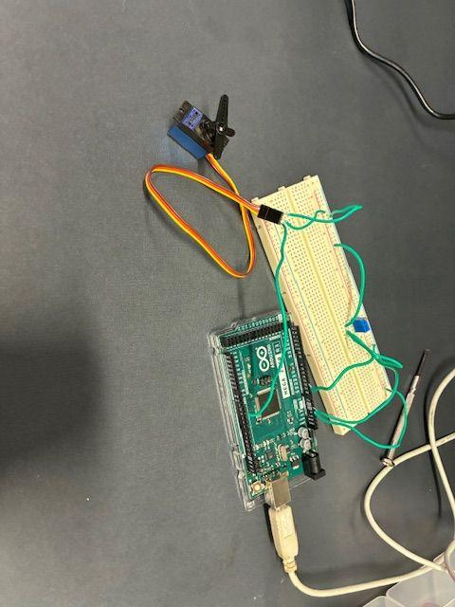

**Figure 1:** The final wiring of the lab is shown with the potentiometer, the servo motor, and the Arduino.

The center pin of the potentiometer was connected to the analog in pin A2 on the Arduino, the 5V power was connected to the pin on the dial’s side, and the potentiometer was grounded on the pin opposite the dial, following the diagram in Figure 2. The input from the potentiometer was measured in Simulink using the Analog Input block in the Arduino, with pin number 2 selected and sample time of 0.01. This block outputs the voltage of analog pin 2 as a digital value between 0 and 1023. The Analog Input block was connected to the inputs of a display block and a scope block to monitor the signal that was being received. Once the signal was being correctly received, the next goal was to power the motor. The motor was wired according to the diagram shown in Figure 3.

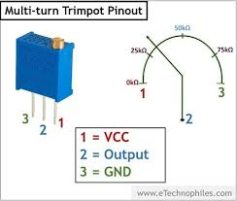**Figure 2:** The wiring diagram for the potentiometer is shown

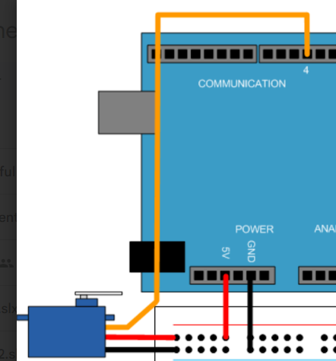

**Figure 3:** The wiring diagram for connecting the servo motor to the Arduino is shown

The brown pin was connected to ground, the orange pin was connected to the 5V source, and the yellow pin was connected to the 4 pin of the Digital PWM section of the Arduino. In Simulink, the Standard Servo Write block was used to send a power signal to the servo motor. This signal that is sent to the servo can be anything between 0 and 180, so to test the communication, a triangle wave on [0, 180] was sent to the motor. The signal was made using a desired shaft angle block. The vector of output values was [0:180 179:-1:1], and the sample time was 0.01. With this input, the servo motor turned on and rotated clockwise and counterclockwise over and over, following the triangle wave. Finally, to use the potentiometer to enable the servo motor, nothing was changed with the wiring; all that was needed was a switch block. A switch block takes 3 inputs. Inputs 1 and 3 are the signals that will be sent based on whether input 2 meets some threshold. If signal 2 satisfies the criteria, input 1 is passed through. If signal 2 does not, input 3 is passed through. In this lab, signal 1 is the triangle wave, signal 2 is the input from the potentiometer, and signal 3 is 0. The threshold can be set to any value between 0 and 1023 because those are the values that are output by the Analog Input block in Simulink. 330 was chosen for this lab, and when the potentiometer was turned so that signal 2 became greater than 330, the triangle wave was passed through the switch and the motor correctly turned to match the triangle wave (Figure 4). A final feature was implemented so that Simulink could control the motor and skip the potentiometer. A manual switch comes after the switch block. It can either pass the switch block’s output or skip the switch block and directly pass the triangle wave through.

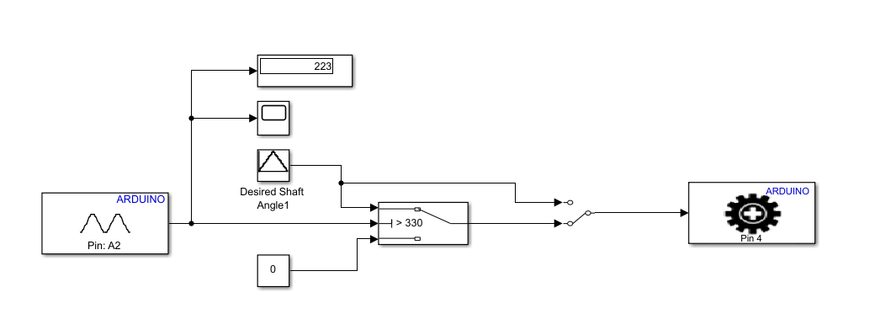

**Figure 4:** The Simulink block diagram that was used to conduct the lab.

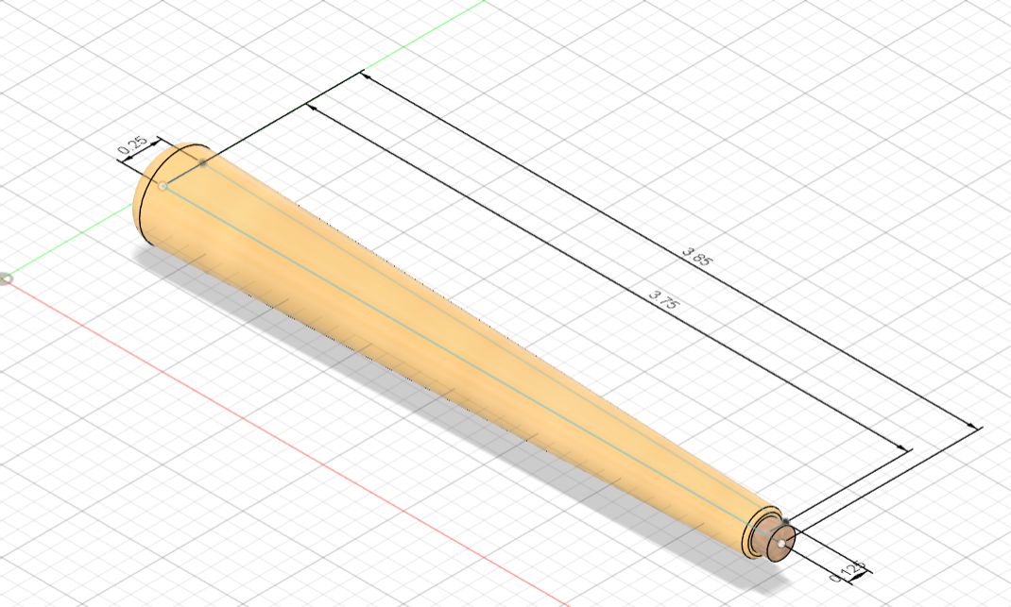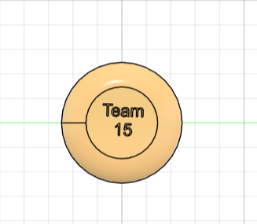

**Figure 5:** The dimensioned 3D model for the pool stick is shown and labeled. Note: the team 15 logo shown is found on the wide end of the stick.

The 3D model was created in AutoCAD Fusion. In a 2D plane, a straight horizontal line was made with two lines pointing vertically at its ends. One endpoint line was half an inch and the other was 1 inch. They were connected with a fourth line to make a trapezoid shape, and revolved around the original line to create a pool stick (Figure 5).

**Results and Discussion**

Once the circuit was built and the block diagram was programmed, the Arduino was run. The potentiometer graph was immediately displayed on the laptop screen. As it was turned counterclockwise, the reading on the graph went up; as the potentiometer was turned clockwise, the reading went down (Figure 6). When the reading crossed 330, the threshold that was set, the motor turned on. It swept from position 0 to 180 and back, following the triangle wave that was made in the Desired Shaft Angle block. The manual switch that comes after the threshold switch in the Simulink block diagram was flipped to verify Simulink control, and the motor continued to turn regardless of the status of the potentiometer.

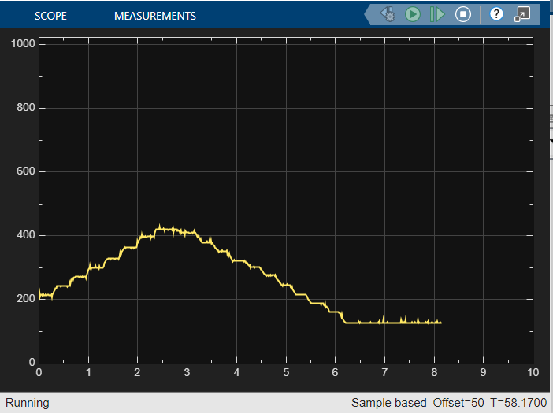

**Figure 6:** The plotted output from the potentiometer over time. Note: each jump in the graph is a twist of the dial on the potentiometer.

It is apparent from the behavior of the motor and the display on the plot that this experiment was successful. The motor behaved as was expected, and the configuration is repeatable and scalable: the two main goals of this experiment were accomplished.

**Conclusions and References**

The equipment used in this experiment functioned well for robot control, but there are a few potential problems that could arise with the equipment. The potentiometer reading is noisy (± 10) when it gets received by the Arduino, which means that if it is left on the 330 line, it could toggle the motor switch on and off rapidly instead of staying smooth. Another potential problem that could arise is with the Simulink software itself. It took about a minute for the program to compile and run each time it was tested. If a program that has less than 10 simple blocks is taking a minute to compile, it is conceivable that much larger and more complex programs could take much longer to compile. This would significantly slow development time of future programs.

The 3D printer will be very useful for projects in the future. The ability to cheaply and quickly design and build 3D models will prove to be immensely beneficial in the prototyping process of projects. A 3D printer could make a mount for the pool stick or for the camera, it could make a stable and consistent base for the electronics, and it could be used to help the aesthetics of the project with designs on the side of these mounts and bases. Each of these contribute to a different aspect of the design and the ability to 3D print them means that more effort can be put into the development of the programs and circuits that will be used in the projects.

In the process of determining how to solve this problem, we learned where to find things around the physical lab such as wires, and wire cutters, potentiometers, and screwdrivers; we learned to navigate the Simulink software; and we learned a little bit about the ways that we work as a group. The group figured out a schedule of work and got on good terms with each other, which has led to healthy communication. This will be essential as we continue to build more and more complex projects.